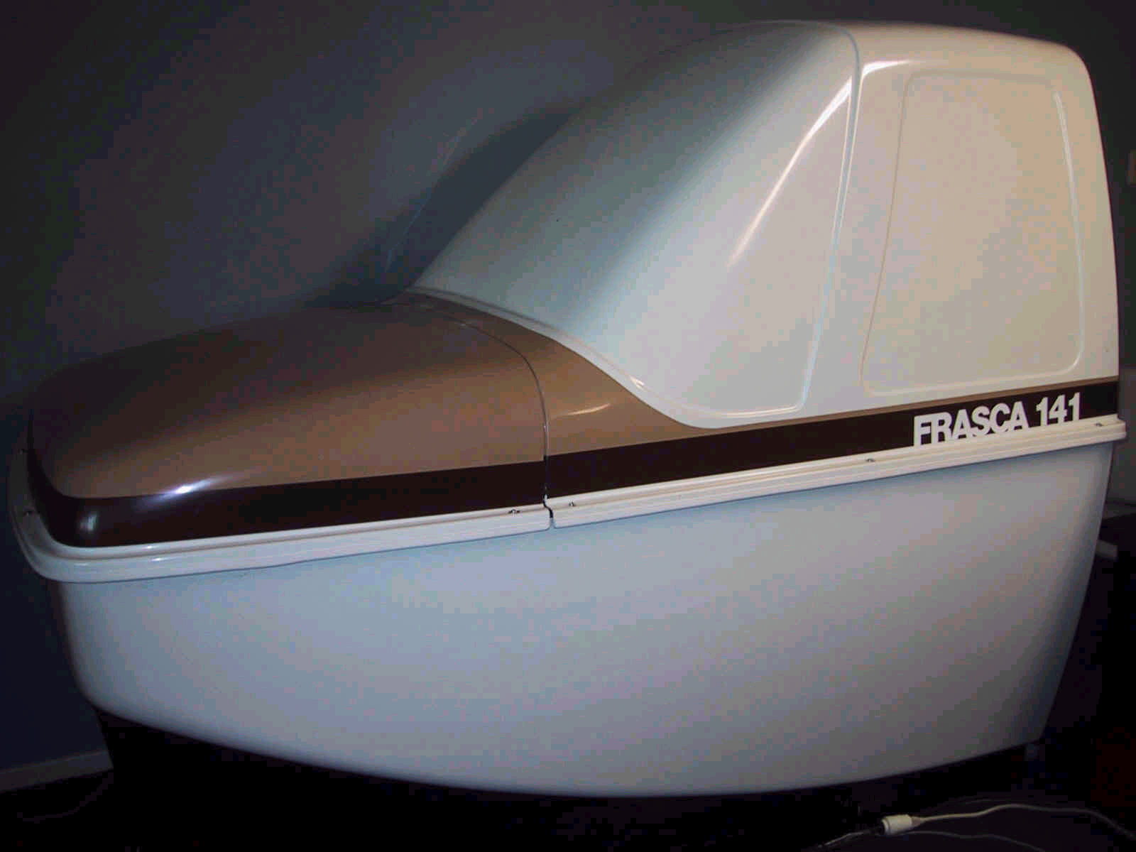
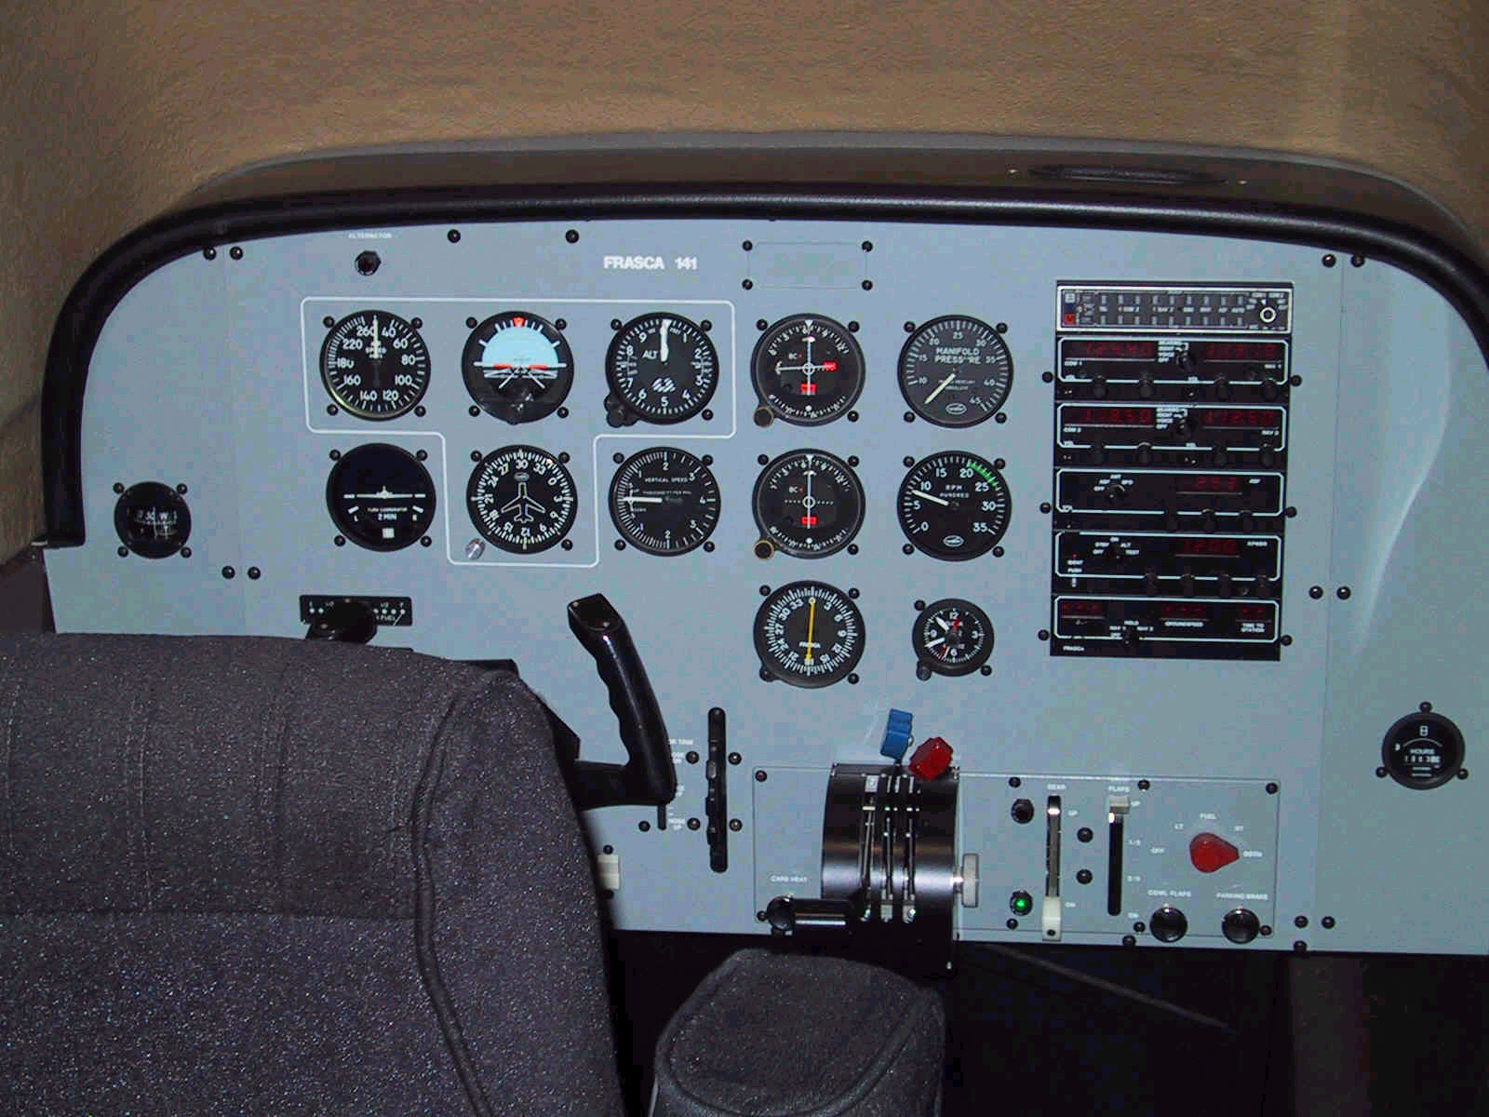
Frasca 141 Single Engine
FAA Approved BATD Simulator

Model Includes
- Half Scale enclosure, single pilot captain chair & inertial reel seat belt. Ipad yoke mount with USB power connector
- Customer rheostat glare shield led panel lighting package
- Full flight instrument panel, Airspeed, attitude indicator, altimeter, turn coordinator, directional gyro, VSI, and all engine instrumentation.
- Landing gear selector position lights.
- Flap selector and indicator.
- No Visual
- High speed-complex performance modification
- Avionics- Dual nav/com radios, localizer and glide slope ,DME
- audio panel complete with nav-aids and marker beacons, transponder and Non-directional beacon receiver and indicator.
- Tracker/ Plotter- Uses standard Jeppesen and NOS instrument approach and area navigation charts.
- World wide programmable data base.
- Remote Instructor’s console- Incorporates all instrument fault panel, wind and weather ceiling and visibility’s, wind shear, turbulence and instant aircraft repositioning.
Frasca 141 BATD Simulator FAA approved FAR 61&141
Approved for PVT. Pilot 2.5 hrs.
Approved for Initial IFR rating 10Hrs
Recurrent 6 approaches and Holding
Instrument Proficiency Check 85% Sim (15%) Aircraft.
Regional Airline Prep & (LOFT) Line Orientation Training

FOR SALE Price Reduced $7500.00
SIMULATORBROKER.COM IFRVNY@AOL.COM 818-371-8653

